CS691 – Computer Science, Spring 2021

Pace University



# 

# SYSTEM TEST PLAN

# 

# 

# UnitedTune

Authors: John Brilhart, Ge Ou, Revati Deshmukh, Jay Patel

Project Manager: John Brilhart

Date: 4/12/21

**Table of Contents**

**SYSTEM TEST PLAN**

**UnitedTune**

INTRODUCTION **3**

TESTING SCOPE **3**

TESTING OBJECTIVES **3**

Features to be Tested 3

Features not to be Tested 4

TEST PROCESS DEFINITION **5**

Test Process Phases and Tasks 5

Deliverables 6

APPROACH TO SYSTEM TESTING **6**

Approach to Functional Testing 6

**ENTRY/EXIT CRITERIA** **6**

Entry Criteria 7

Exit Criteria 7

ENVIRONMENTAL NEEDS **8**

ROLES AND RESPONSIBILITIES **9**

TEST CYCLES AND SCHEDULE **10**

RISKS AND CONTINGENCIES **11**

# INTRODUCTION

This document explains the test plan for the UnitedTune web application. The system test plan will give insight to the project stakeholders about testing scope, objectives, and the approach that will be taken during system testing. This document will also cover the features that will be tested, what entry/exit criteria will be used to determine when to start and stop testing, and a look at possible risks.

# TESTING SCOPE

Our testing scope is limited to the following functioning areas:

* Customer module
* Musician module
* Admin Module
* Booking Module
* Advertisement Module
* Customer Account Module

The technical scope will include the following architectural components:

* Web browser
* Web server
* Application Server
* Database Server

# TESTING OBJECTIVES

The focus of testing will be on functional testing with the goal of evaluating the features that have been implemented and that they perform as expected.

The development of the tests come from several documents developed during the requirements definition phase including:

* Business Requirements Document (BRD)
* User Stories( Functional requirements)
* Requirement Composition Table(RCT)

# 

## Features to be Tested

This section lists all core features that will be tested grouped by the application modules below. Reference the RCT to view the implemented crosscuts that will be tested.

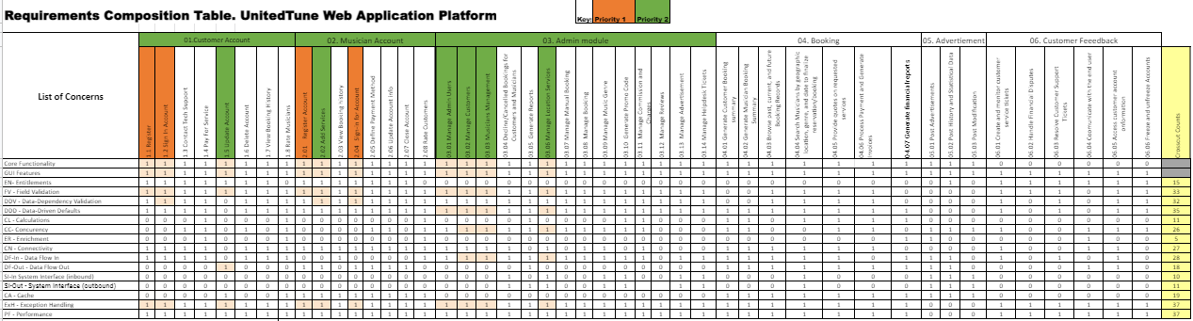

**Customer:**

* Register
  + Testing this feature will illustrate whether a customer can successfully register their account so that in the future they can sign into the customer portal.
* Sign in Account
  + Testing this feature will illustrate whether a customer can successfully sign their account so that they can access the customer portal.

**Musician:**

* Register
  + Testing this feature will illustrate whether a musician can successfully register their account so that in the future they can sign into the customer portal.
* Sign in Account
  + Testing this feature will illustrate whether a musician can successfully sign their account so that they can access the customer portal.

## Features not to be Tested

Due to time constraints many functional and supplementary requirements have not been implemented. Because of this only priority one feature and crosscut concerns are being tested. The additional features that are not being tested are listed as priority two or lower on the RCT. Additionally due to technological limitations non functional features have not been implemented so they will also not be implemented.

|  |  |
| --- | --- |
| **Category** | **Requirements** |
| **Usability** | The application GUI will provide a user-friendly intuitive design with all the features clearly displayed for the user |
| **Usability** | The application navigation will be self-explanatory by clear and concise descriptions and names of each section, as well as features will be clearly evident by proper location and naming |
| **Usability** | Accessibility will be supported for the disabled users as well |
| **Performance** | The application will be supported on different operating systems and browsers, and should not impact the user’s system capabilities |
| **Performance** | The application will be available for 24/7 without any interruptions, and regular maintenances will be scheduled to support the application |
| **Performance** | The application will support the concurrency where the users will be able to simultaneously browse the app, login & subscribe, make payments, book the musician |
| **Performance** | The application will have short response time to all requests and all the features should be available and not impacted by latency |
| **Security** | The application will be using the automated daily & weekly audits to detect the vulnerabilities. |
| **Security** | The application will use HTTPS protocols for any data exchanges, enforced TLS for all the email communications, and other encryptions that will be maintained on the server |
| **Database** | The application will be using the MySQL database |
| **External System** | The application will be able to interface with the external data feeds from and to payment merchants, ad agencies, social media websites, etc… |

# TEST PROCESS DEFINITION

## Test Process Phases and Tasks

The test process consists of the following 5 phases with several tasks for each:

**Test Planning**

* Define the scope and objective for testing
* Define roles and responsibilities
* Define approach for testing

**Test Design**

* Decide requirements for testing
* Identify several test ideas and create a approach for designing the test cases
* Decide test specifications
* Mesure test requirements

**Test Preparation**

* Create test environment
* Provide test idea
* Setup application in test environment

**Test Execution**

* Execute test cases
* Identify and record application defects
* Evaluate stability
* Validate all implemented features

**Test Reporting**

* Summarize and report the results from the administration of the tests
* Evaluate test exit criteria
* Create a completion report for stakeholders
* Get signoff on testing by stakeholders

## Deliverables

On this project, the test process deliverables include:

* System Test Plan document
* Test Design specifications
* Test Case specifications
* Software Defects
* Test Execution Logs
* Test Completion Report

# APPROACH TO SYSTEM TESTING

## Approach to Functional Testing

The approach for all functional tests done will be Blackbox testing. Blackbox testing is a method of testing where the internal structure of the application is not known to the tester. This is ideal for functional tests and considering our tester and QA were not involved in the design of the application.

* All tests were executed from the user perspective, with the tester executing the tests over Zoom with remote control. Tests were executed by following steps laid out in each individual test case.

# 

# 

# **ENTRY/EXIT CRITERIA**

Each test type requires distinct entry and exit criteria for testing phases. It ensures that the objectives of the test strategy and product requirements are met. Additionally, the QA professionals can utilize the outlined entry-exit criteria of the test strategy to map and analyze before sign off the outcomes. In this section, we will see the Entry and Exit Criteria at different levels in Software testing. The following points need to be considered to understand the criteria.

Ideally, the QA team does not proceed with the next phase until the exit criteria of the current phase meets. The entry criteria should include the completion of exit criteria of the previous phase. In real time, it is not possible to wait for the next phase until the exit criteria is met. Now, the next phase can be initiated if the critical deliverables of the previous phase have been completed.

And thus it is important to define entry and exit criteria in each phase of Software Testing

## Entry Criteria

Entry Criteria can be defined as specific conditions; or, all those documents which are required to start a particular phase of Software Testing Life Cycle and should be present before entering any of the Testing phase. It includes:

* **Requirements Documents:**Requirements Document available (both functional and non-functional) and application architecture document available. We are testing with respect to the requirements listed in BRD and BRM. So, ensuring all the requirements would be fulfilled is our main entry criteria
* **Acceptance criteria:** Acceptance criteria is defined. After listing all the requirements,we would have a clear idea about what a feature should which would be our acceptance criteria.
* **Application build and test environment:** Application build is produced and deployed to the test environment and the test environment is ready for testing. We are using PHP Myadmin server for frontend code and database design. Also a machine with atleast 8GB RAM and other prerequisites should be present before commencing the test
* **The testing documents:** Testing designs, test case specifications and system test plan are complete and approved. Test designs and test plan also should be available
* **Testable code & test data:** Complete or partially testable code is available and sufficient and desired test data is available. We have user and musician register created and ready to be tested.

## Exit Criteria

Exit Criteria can be defined as items/documents/actions/tasks that must be completed before concluding the current phase and moving on to the next phase. Exit criteria is a set of expectations; this should be met before concluding the Software Testing phase. It includes:

* Signed off RTM
* Test automation feasibility report signed off
* Verify the deadlines meet or budget depleted.
* Verify the execution of all test cases is according to the test plan
* Verify that we have desired and sufficient coverage of the requirements and functionalities test.
* Verify all the identified defects are corrected and closed.
* Verify no high priority or severity or critical bug has been left out.

# **ENVIRONMENTAL NEEDS**

Each and every process needs a controlled environment with desired requirements and specifications to successfully carry out the executions of the intended tasks, processes and activities. The environment for testing is created by integrating the required hardware and software along with proper network configuration and necessary settings. The list of things that contributes towards the environment set up for the purpose of testing may consists following stuffs or factors:

* Software product, on which testing needs to be performed.
* Operating system, Testing Server and Database.
* Test Data and Data configuration.
* Network connectivity and configuration.
* Hardware devices such as machines or PCs and Simulators if needed.
* Test Framework and tools like automation tools and debugging tools.
* Third party software or other software for user purposes.
* Interfaces between the system and applications.
* Documentation such as user manual, etc.
* Knowledge of customer's and business requirements.

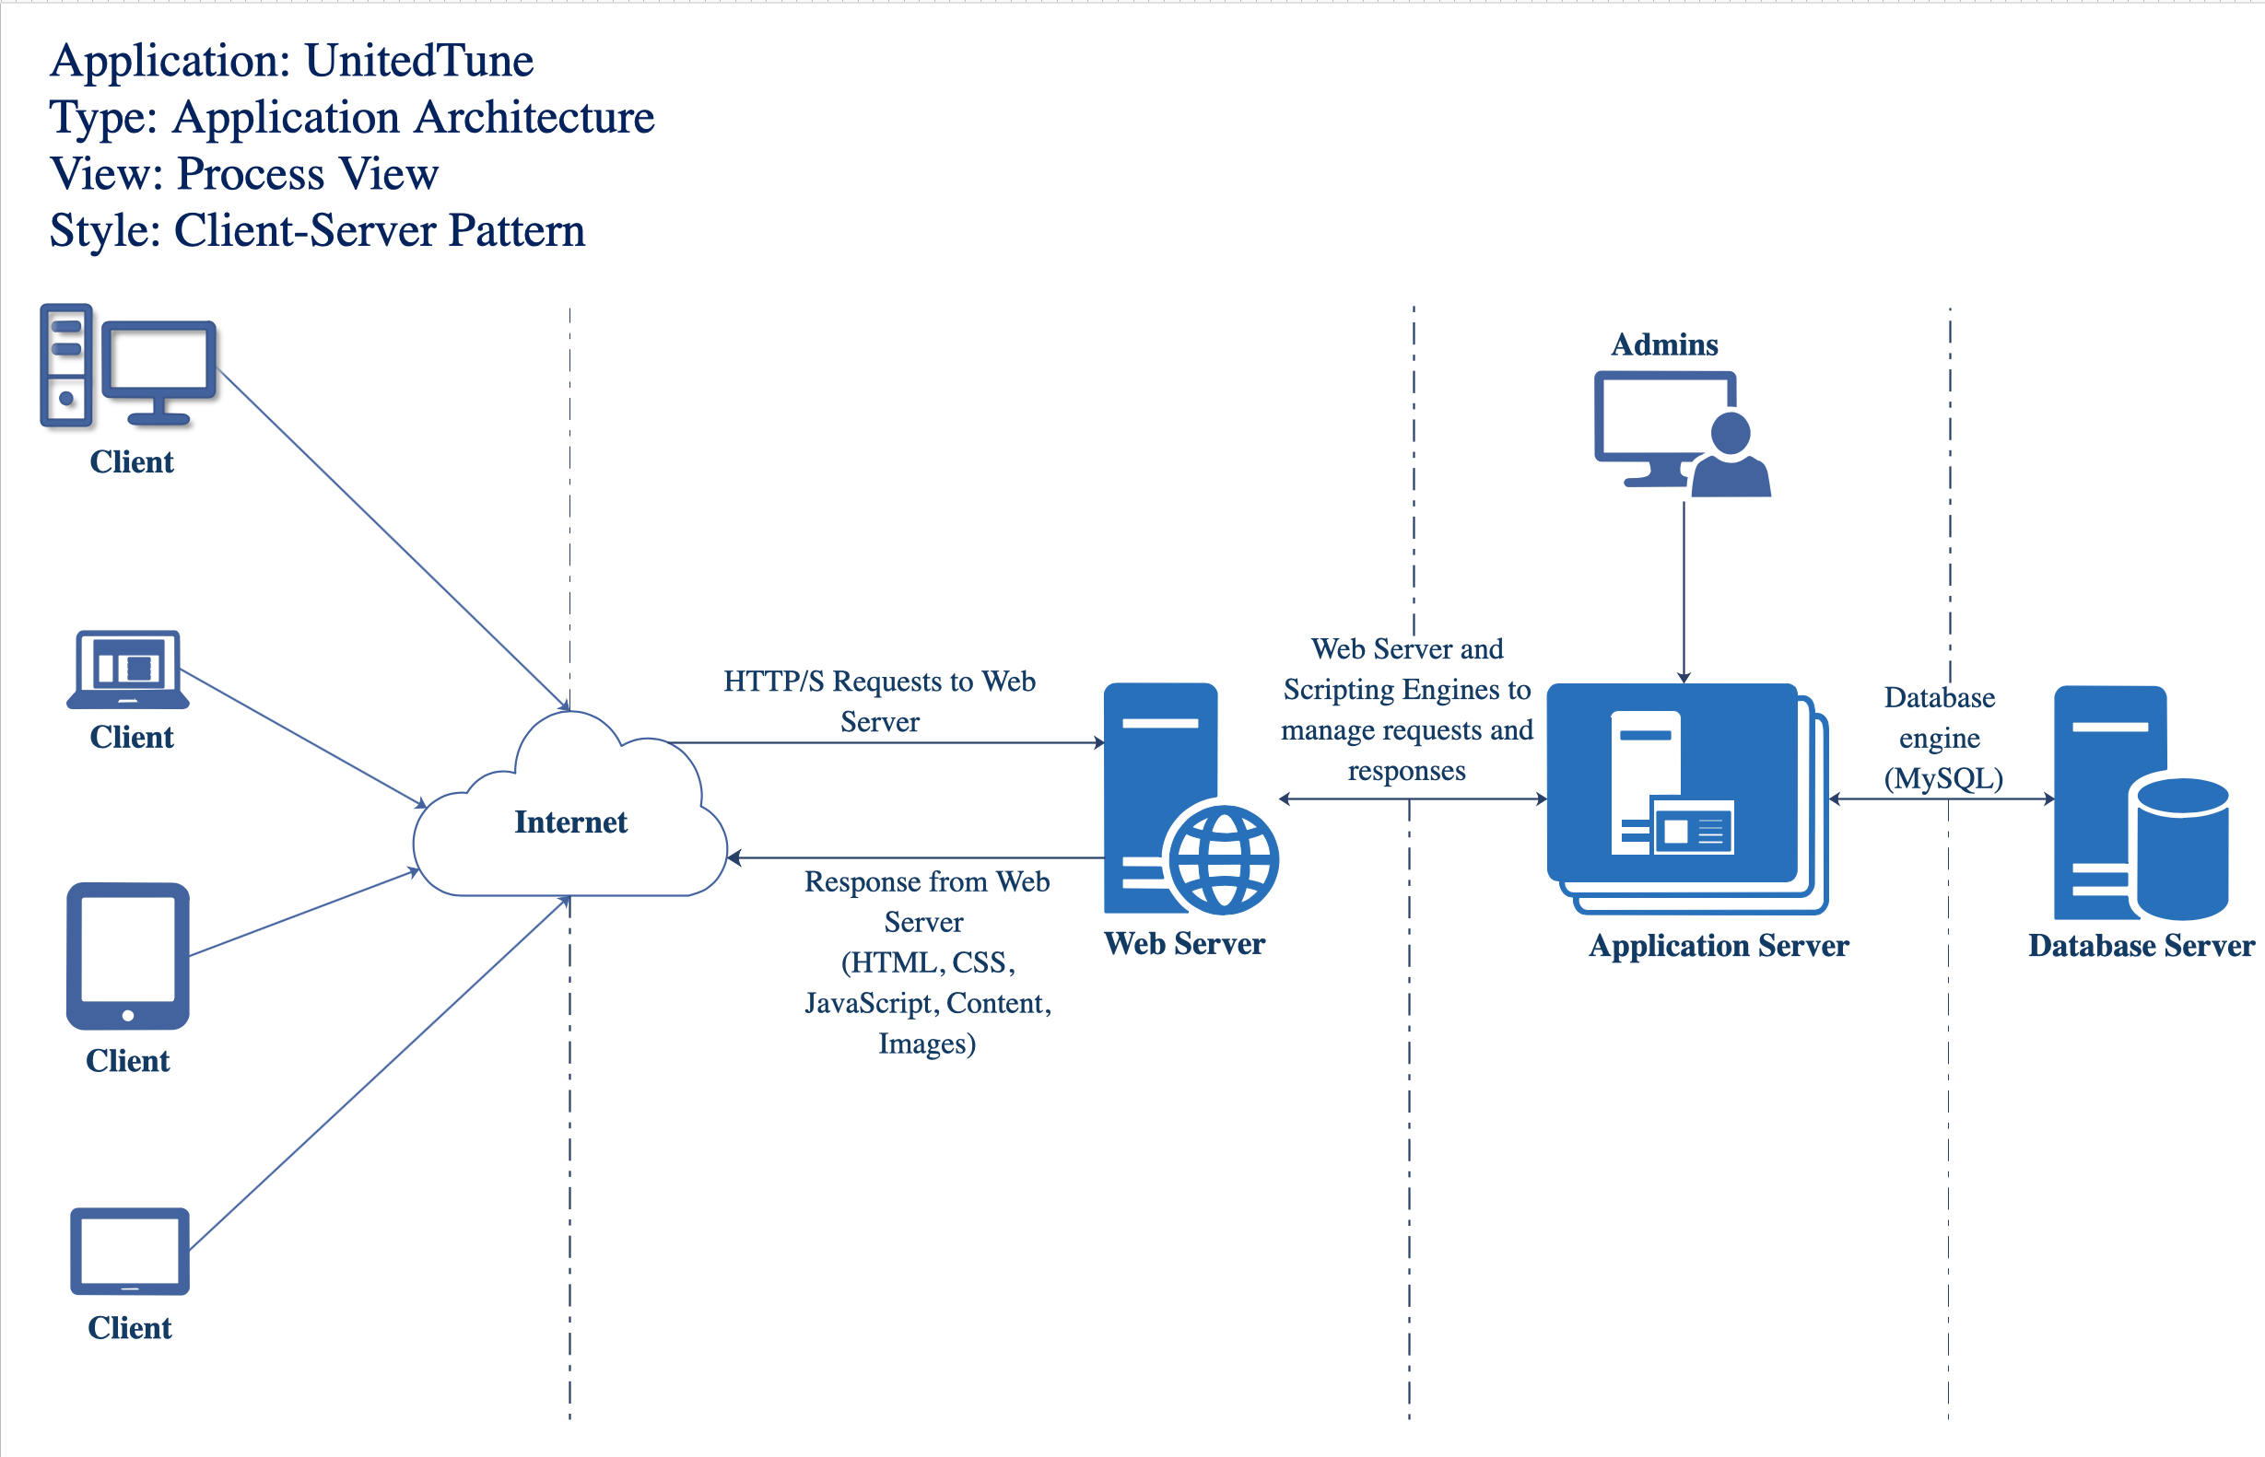

# ROLES AND RESPONSIBILITIES

There are three very important roles that have a heavy load of responsibility in the Software testing phase. Following table gives a brief description of different roles and their responsibilities during the testing phase of an application

|  |  |
| --- | --- |
| **Role** | **Responsibilities** |
| Test lead/manager | * Defining the testing activities for subordinates – testers or test engineers. * To check if the team has all the necessary resources to execute the testing activities. * To check if testing is going hand in hand with the software development in all phases. * Prepare the status report of testing activities. * Updating Project Manager regularly about the progress of testing activities. |
| Test engineers/QA testers/QC testers | * To read all the documents and understand what needs to be tested. * Based on the information procured in the above step decide how it is to be tested. * Inform the test lead about what all resources will be required for software testing. * Develop test cases and prioritize testing activities. * Execute all the test cases and report defects, define severity and priority for each defect. * Carry out regression testing every time when changes are made to the code to fix defects. |
| Project Manager & Product Owner | * Responsible and accountable for the successful execution of the Test Phase. * lead the Integrated Project Team that accomplishes the Test Phase activities and deliverables. * In conjunction with the Business Owner and CIO, establish the test team and create the Test Files/Data. |

# TEST CYCLES AND SCHEDULE

The system test execution will be conducted as three test cycles as follows:

Cycle 1. focuses on testing the Customer Account module.

Cycle 2. focuses on testing the Musician Account module.

Cycle 3. concentrates on testing the Admin module, Booking module, advertising module and customer feedback module.

See the schedule of the test execution cycles in the project plan.

# RISKS AND CONTINGENCIES

This section highlights a few potential risks and contingencies that may happen during the system testing.

▪ Limited testing resources may result in a delay.

▪ Any changes on the scope objectives can cause a delay or extra work.

▪ A large number of defects require a longer time to fix defects and complete testing.

▪ Miscommunication of the team members can have a negative impact on the testing progress.

▪ Inaccurate documentation of testing may cause security issues.

▪ Any changes in the overall goals of application during testing could cause further delays.

▪ Team members in different time zones may cause inconvenience in communication and difficulty in arranging meetings to discuss together.